WORLD’S MOST ADVANCED OPEN SOURCE object-RELATIONAL DATABASE
________________________________________________________________________________
Applications & Tools:
PGAdmin 4 (PostgreSQL GUI)
Dummy & Random Data Generator Tool: https://www.mockaroo.com/
________________________________________________________________________________

Install Postgre on linux

1. sudo apt-get update
2. sudo apt-get upgrade
3. sudo apt-get install postgresql postgresql-contrib
________________________________________________________________________________

Start PostgreSQL CLI
- service postgresql status //running status of PostgreSQL
- sudo su postgres //login as postgres user
- psql //start PostgreSQL cli in Terminal
- \q //to exit PostgreSQL cli
_______________________________________________________________________________

In PostgreSQL CLI (psql //start PostgreSQL cli in Terminal)
- \l (small L) //list of databases
- \du //list of users of PSQL DBMS
- CREATE DATABASE test ;
- DROP DATABASE test ;

- ALTER USER postgres PASSWORD 'admin'; \\ to alter password of a user
- \c test //to connect to a database;

________________________________________________________________________________
Connect to database (after loging as sudo su postgre)

psql --help
Default Hostname: "/var/run/postgresql"
Default Port: "5432"
Default Username: "postgres"
-Default Password- I had set my postgresql password admin

CMD: psql -h localhost -p 5432 -U postgres DB_name
Exit: \q
or
\l
\c DB_name

________________________________________________________________________________
In a Database (\c db_name //to connect to a database;)

- CREATE TABLE employee(
id BIGSERIAL NOT NULL PRIMARY KEY,
age INT NOT NULL,
full_name VARCHAR(60) NOT NULL,
gender VARCHAR(7) NOT NULL,
dob DATE NOT NULL,
);
BIGSERIAL == BIGINT it increment by themselves.
- \d employee; //structure of table
in pgadmin: Servers-> learn->db_name->Schemas->public->Tables
- DROP TABLE table_name;

- INSERT INTO table_name(col1,col2,...) VALUES(102, ’val2’ , ....) ;
INSERT INTO table_name VALUES(102, ’val2’ , ...., ‘valn’) ; //no need to mention col_name if we are inserting in all colmns;
EX: INSERT INTO person (first_name,last_name,gender, dob) VALUES (‘Anne’, ‘Smith’, DATE ‘1988-01-09’) ;

- SELECT * FROM table_name;
SELECT col1, col2 FROM table_name;
SELECT DISTINCT col1, col2 FROM table_name;

- SELECT DISTINCT col1, col2 FROM table_name WHERE col1=’fdddff’;
- AND || OR || ORDER BY col_name | col1, col2 | ASC (default) | DESC
- LIMIT 9 | 2*3-1;
- UPDATE table_name SET col_name = ‘new updated val’ WHERE col_name2 = ‘val to search’ ;
- DELETE FROM table_name WHERE col_name2 = ‘val to search’ ;
- DROP TABLE table_name; (erase the table from db + unrestorable + no log is maintained)
- TRUNCATE TABLE table_name; (delete all the records of the data + log is maintained)
- ALTER TABLE:
ADD NEW COL =>ALTER TABLE table_name ADD newcol_name datatype;
DROP A COL =>ALTER TABLE table_name DROP col_name;
MODIFY A COL=>ALTER TABLE table_name MODIFY col_name newdatatype;
- WHERE col_name BETWEEN val1 AND val2; ==== colname>=val1 AND colname<=val2 ;
- Comparison Operators: Equal to (==): = , Not Equal to (!=): <> , rest....is same
- WHERE col1 IN (val1, val2, val3);
- WHERE col1 LIKE ‘p%’ ; OR ‘_p’ //LIKE is CASE SENSITIVE
WHERE col1 ILIKE ‘p%’ ; OR ‘_p’ ==(LIKE ‘P%’ + LIKE ‘p%) //ILIKE is CASE IN-SENSITIVE
- GROUP BY:
SELECT country, COUNT(*) FROM person GROUP BY country ORDER BY country;
- HAVING: (must be after GROUP BY and before ORDER BY)
SELECT country, COUNT(*) FROM person GROUP BY country HAVING COUNT(*) > 40 ORDER BY country;
- AGGREGATORS : MIN, MAX, COUNT,etc
MAX: SELECT MAX(price) FROM car;
Eg: SELECT make, MAX(price) FROM car GROUP BY make;
MIN: SELECT MIN(price) FROM car;
AVG: SELECT AVG(price) FROM car;
ROUND: SELECT ROUND(AVG(price)) FROM car;
EG: SELECT make, price,ROUND(price*.10 , 2) AS discount FROM car;
//it will show 10% price of cars upto 2 precision.
SUM: SELECT make, SUM(price) FROM car GROUP BY make;

- Handling Null Values:
SELECT email FROM person; //it will print values all records on email col and if it is NULL blank will be print.
SELECT COALESCE(email, “<Default Value>”) FROM person; //it will print Default in place of NULL.
- Handling Divide by 0 Error:
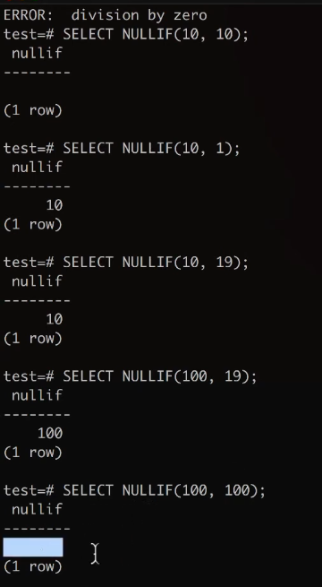
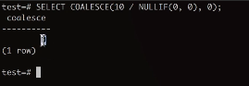
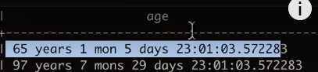
- Timestamp and Date
NOW()
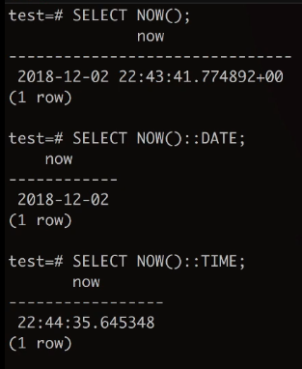
INTERVAL
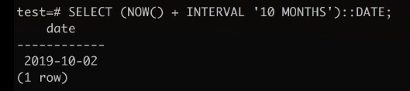
AGE()

- Handling CONSTRAINT:
Drop all CONSTRAINTs including UNIQUE and PRIMARY KEY.:
Add Back Primary Key:
Add UNIQUE Constraints:
Add CHECK Contraints:
Add ON CONFLICT Constraints:
- Update Records:
- Execute a file in PostgreSQL
- DELETE a record:
__________________________________________________________________________

Relationship:
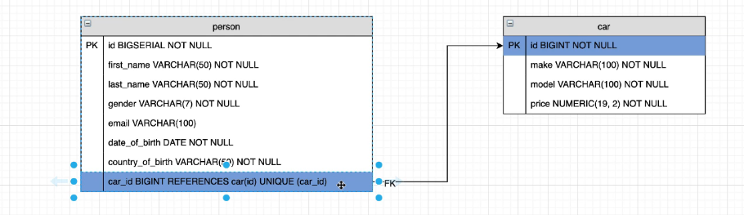
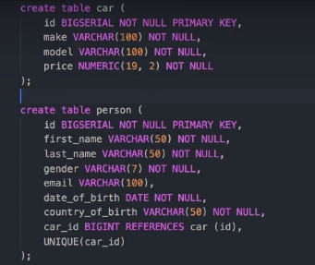
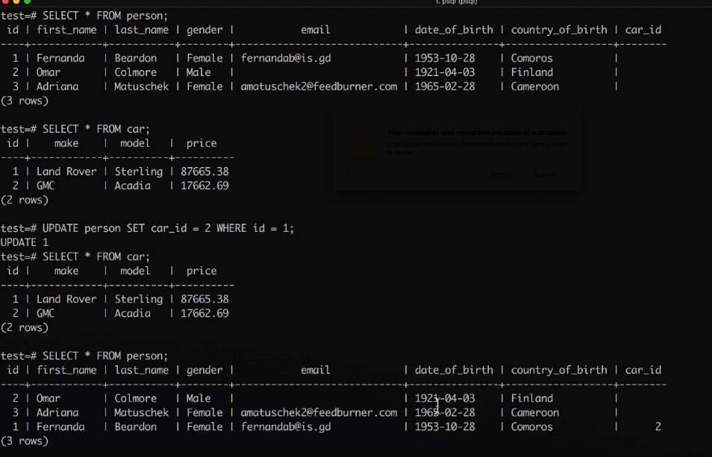
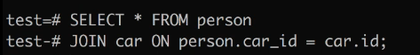
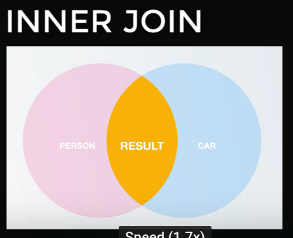
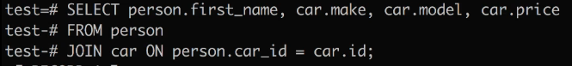
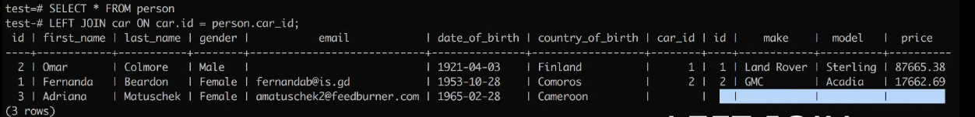

- JOINS:
Inner Join
LEFT JOIN





